Investigation of Polyethylene Terephthalate in Different Thickness with Coincidence Doppler Broadening Spectroscopy

Junyoung Lee a,b, Jaegi Lee a*, Gwang-Min Sun a, Young Rang Uhm a, Sung-Joon Ye b

aNeutron and Radioisotope Application Research Division, KAERI, 111 Daedeok-daero 989beon-gil, Daejeon, 34057

bProgram in Biomedical Radiation Sciences, Department of Transdisciplinary Studies, Graduate School of Convergence Science and Technology, Seoul National University, Seoul, 08826

\**Corresponding author: jgl@kaeri.re.kr*

1. Introduction

Positron annihilation spectroscopy is mainly divided into two methodology: positron annihilation lifetime and the Doppler broadening of the annihilation gamma-rays. When the positrons are injected to a dense matter, they will be thermalized by the repulsive force from the nucleus. The energies of the positron annihilation photons are shifted by the Doppler effect, where the quantity of the gamma-ray energy shift is correlated to the momentum distribution of electrons. The core electrons which have high momentum compared to the valance electrons provide distinctive information of the carbon covalent bond like a C=O group. Nevertheless, the detection of annihilation gamma-rays from the core electrons is a challenging task, due to both the rarity of core electron annihilation events and the comparatively dominant Compton background signal acting as a noise. In order to enhance the signal-to-noise ratio of the energy spectrum of the annihilation gamma-rays, the coincidence Doppler broadening spectroscopy (CDBS) with two germanium detectors were designed[1]. In this setup, the peak to the background ratio is dramatically improved in the tail region and the contribution of the core electrons can be easily extracted.

Polyethylene terephthalate (PET) is one of the superb candidate materials for coating film to block the low atomic number materials. During the PET manufacturing process, a PET sheet with a few hundred micro-meter thickness is expanded by the specific process. In this work, the PET samples with different thickness or manufacturing process were studied by CDBS.

2. Methods and Results

2.1 System Setup

The coincidence Doppler broadening spectroscopy was performed using two HPGe detectors (Ortec GMX40P4-76), a dual 5-kV detector bias supply (Ortec 660) two amplifiers (Ortec 570), and a coincidence module (Labo NT24-DUAL). The coincidence module consists of two analog-to-digital converters (ADC) with the maximum 4096 channels and coincidence timing module. The coincidence timing window was set to 1 μs. Two HPGe detectors were separated by 30 cm, the detector positron was diametrically opposed. The ADC channels of two detectors were calibrated by 22Na and 226Ra sources. The prompt gamma-ray energies of 186.1, 242.0, 295.2, and 351.9 keV were used from the 226Ra sources as well as 511-keV gamma ray from the 22Na source was used to make the channel-energy calibration curve. Each measurement lasted for about 20 hours, and the annihilation peaks were at least 8×104 counts. The shaping time of the amplifiers was 2 μs. A 30 μCi 22NaCl source was placed and dried between 2.5-μm nickel foils. The samples sandwiched the 22NaCl source. The direction of the samples to the HPGe detectors was 45° for simultaneous measurements of positron annihilation lifetime spectroscopy.

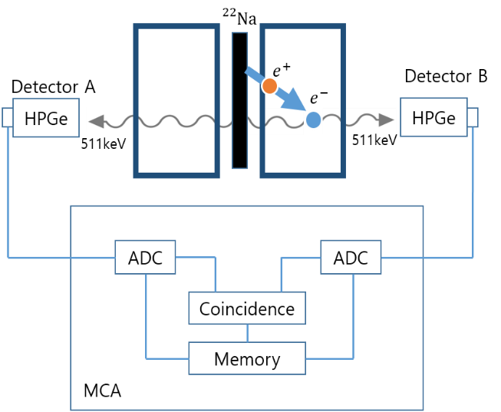

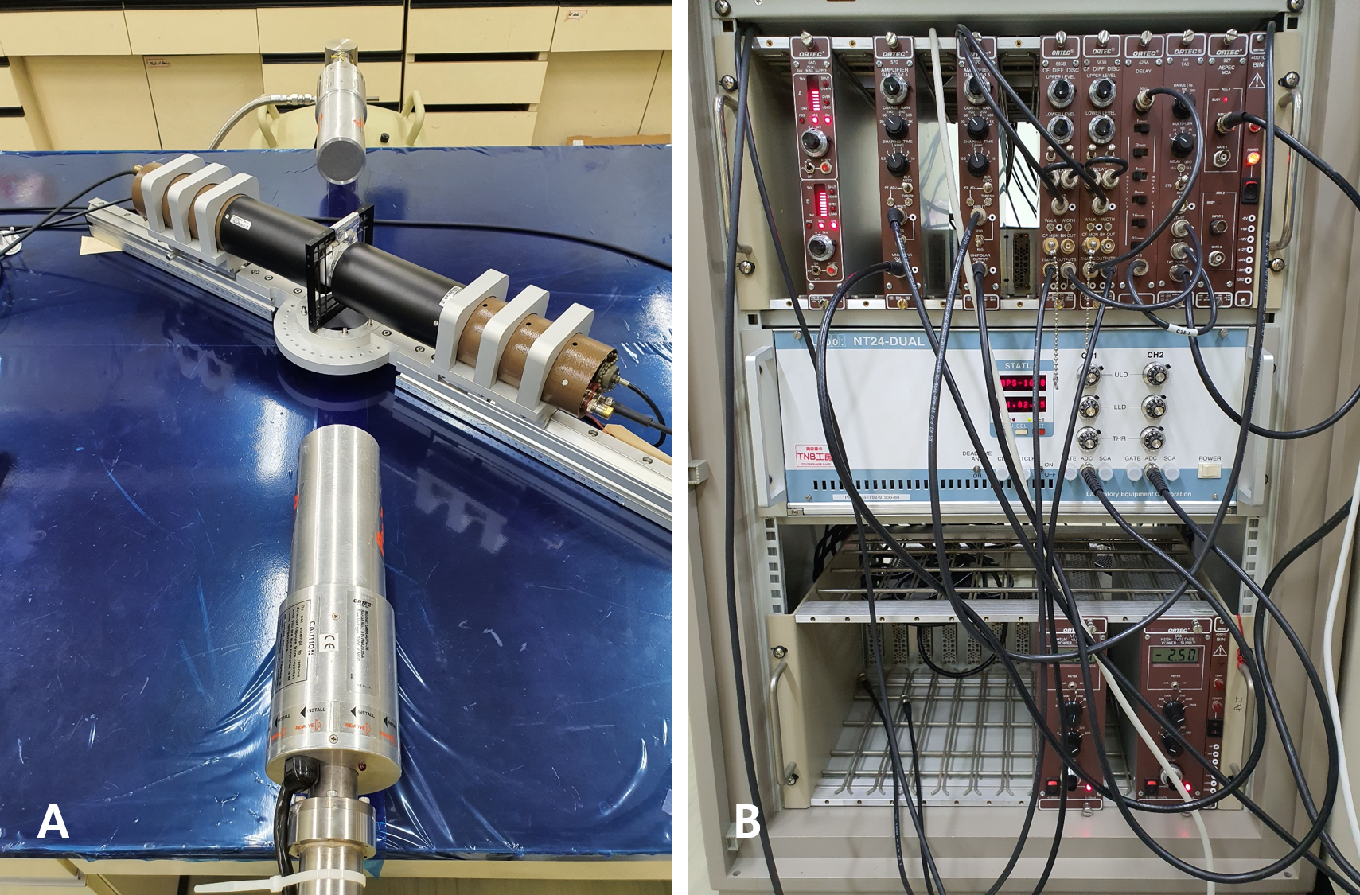

Fig. 1. Output current of the SiC detector for three particles that have been simulated as interacting in the detector randomly in time, with an average event rate of 108 events/s.

2.2 Experimental Result

The horizontal and the vertical bands correspond to the intensities of the annihilation gamma rays of the individual detector. The intense peak at the center corresponds to the counts for E1=E2=511keV

The elliptical region extending diagonally with E1+E2 = 1022keV corresponds to the true Doppler shift. This region is nearly background free

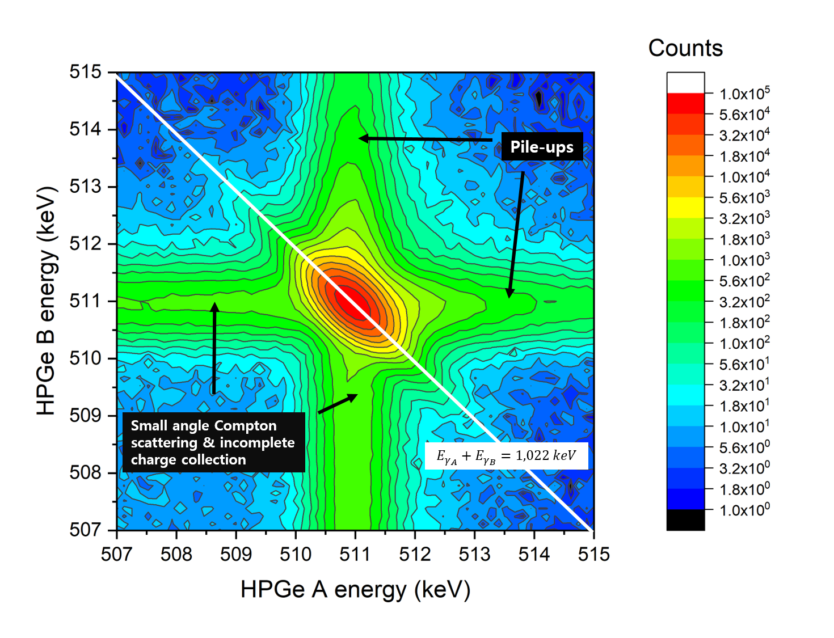

Fig. 2. Output current of the SiC detector for three particles that have been simulated as interacting in the detector randomly in time, with an average event rate of 108 events/s.

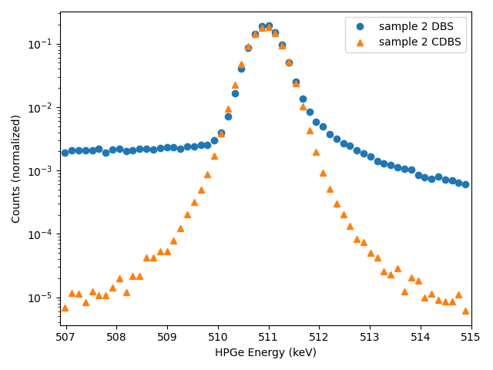

Fig. 3. Doppler broadening spectrum of PET sample measured with a single HPGe detector (blue dots) and coincidence Doppler broadening spectrum of the same sample obtained with two HPGe detectors in coincidence (orange triangle)

The.

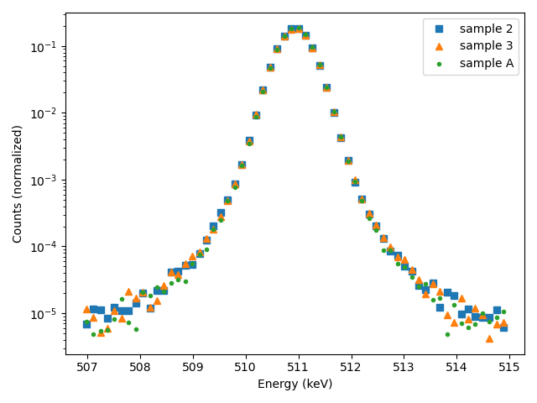

Fig. 4. Coincidence Doppler broadening spectrum from PET samples with different thickness

Table I: Problem Description

|  |  |  |
| --- | --- | --- |
|  | Thickness $(μm)$ | $σ_{CDBS}$ (keV) |
| Sample #1 | 570 | 2.160 |
| Sample #2 | 210 | 2.175 |
| Sample #3 | 50 | 2.139 |

3. Conclusions

Simulation techniques using.

REFERENCES

[1] K.G. Lynn, J.R. MacDonald, R.A. Boie, L.C. Feldman, J.D. Gabbe, M.F. Robbins, E. Bonderup, J. Golobchenko, Positron-Annhilation Momentum Porfiles in Aluminum: Core Contribution and the Independent-Particle Model, Physical Review Letters 38, p.241-244, 1977

[2] P. Asoka-Kumar, M. Alatalo. V.J. Ghosh, A.C. Kruseman, B. Nielsen, K.G. Lynn, Increased Elemental Specificity of Positron Annihilation Spectra, Physical Review Letters, Vol.77, p.2097-2100, 1996

[2] W. J. Davies and R. A. Pethrick, Positron Annihilation Lifetime and Doppler Broadening Studies of Amorphous Fluoroploymer-ploy(2,2-Bis Trifluoro 4,5 Difluoro 1,3-Dioxole), European Polymer Journal, Vol.30, p.1289-1293, 1994.

[3] E. do Nascimento, O. Helene, C. Takiya, and V.R. Vanin, Doppler broadening of positron annihilation radiation: fitting the coincidence spectrum, Nuclear Instruments and Methods in Physics Research A, Vol.538, p. 723-730, 2005.

[2] P. Pikart and C. Hugenschmidt, Novel data evaluation algorithm for Coincident Doppler Broadening Spectroscopy, Nuclear Instruments and Methods in Physics Research A, Vol.750, p.61-68, 2014.

[3] J. F. Ziegler, J. P. Biersack, “SRIM-2000, 40: The Stopping and Range of Ions in Matter”, IBM-Research, Yorktown, NY 2000.

[5] G. Lutz, Semiconductor Radiation Detector, Springer, New York, 1999.

[6] G. F. Knoll, Radiation Detection and Measurement, John Wiley & Sons, New York, pp.612-613, 1999.